Overloaded

💥 What Is Overloaded in Networking (or Computing)?
# Source: AI Source: Provided by: [Data Path: Persons Table -> ID Column: 1, Name_En Column: Motasem Essam] -> From: [ChatGPT] on [12/18/2025]
In networking or IT systems, "overloaded" refers to a situation where a device, service, or network is handling more traffic, tasks, or data than it was designed to manage efficiently, resulting in slow performance, errors, or failures.

🧠 General Definition:
# Source: AI Source: Provided by: [Data Path: Persons Table -> ID Column: 1, Name_En Column: Motasem Essam] -> From: [ChatGPT] on [12/18/2025]
A system is overloaded when the demand exceeds its capacity, causing degraded performance or complete failure.

📡 Examples in Networking:
# Source: AI Source: Provided by: [Data Path: Persons Table -> ID Column: 1, Name_En Column: Motasem Essam] -> From: [ChatGPT] on [12/18/2025]
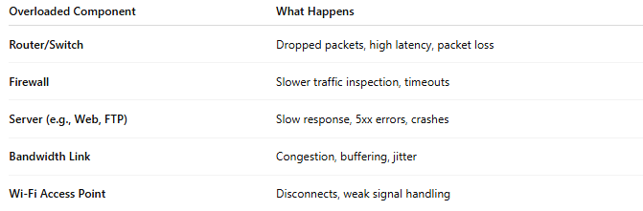
Overloaded Component | What Happens
Router/Switch | Dropped packets, high latency, packet loss
Firewall | Slower traffic inspection, timeouts
Server (e.g., Web, FTP) | Slow response, 5xx errors, crashes
Bandwidth Link | Congestion, buffering, jitter
Wi-Fi Access Point | Disconnects, weak signal handling

⚠️ Signs of an Overloaded System
# Source: AI Source: Provided by: [Data Path: Persons Table -> ID Column: 1, Name_En Column: Motasem Essam] -> From: [ChatGPT] on [12/18/2025]
- ⏳ Slow responses or timeouts
- 📉 High CPU or memory usage
- 📡 Increased latency or jitter
- ❌ Packet loss or failed connections
- 🔄 Services restarting or freezing
- ⚙️ Device temperature increases

🛠 Common Causes of Overload
# Source: AI Source: Provided by: [Data Path: Persons Table -> ID Column: 1, Name_En Column: Motasem Essam] -> From: [ChatGPT] on [12/18/2025]
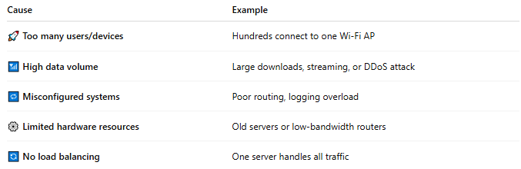
Cause | Example
🚀 Too many users/devices | Hundreds connect to one Wi-Fi AP
📶 High data volume | Large downloads, streaming, or DDoS attack
🔁 Misconfigured systems | Poor routing, logging overload
⚙️ Limited hardware resources | Old servers or low-bandwidth routers
🔄 No load balancing | One server handles all traffic

✅ How to Prevent or Fix Overloading
# Source: AI Source: Provided by: [Data Path: Persons Table -> ID Column: 1, Name_En Column: Motasem Essam] -> From: [ChatGPT] on [12/18/2025]
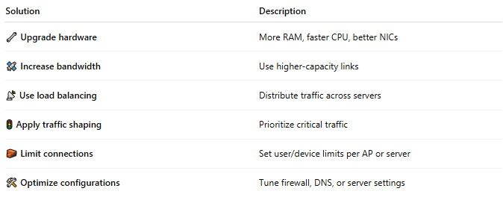
Solution | Description
🔧 Upgrade hardware | More RAM, faster CPU, better NICs
🛰️ Increase bandwidth | Use higher-capacity links
📡 Use load balancing | Distribute traffic across servers
🚦 Apply traffic shaping | Prioritize critical traffic
🧱 Limit connections | Set user/device limits per AP or server
🛠 Optimize configurations | Tune firewall, DNS, or server settings

📌 Summary
# Source: AI Source: Provided by: [Data Path: Persons Table -> ID Column: 1, Name_En Column: Motasem Essam] -> From: [ChatGPT] on [12/18/2025]
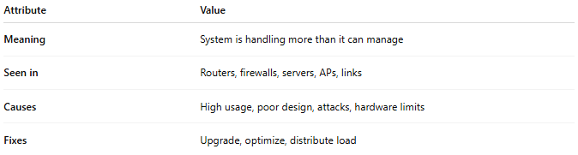

Attribute | Value
Meaning | System is handling more than it can manage
Seen in | Routers, firewalls, servers, APs, links
Causes | High usage, poor design, attacks, hardware limits
Fixes | Upgrade, optimize, distribute load

